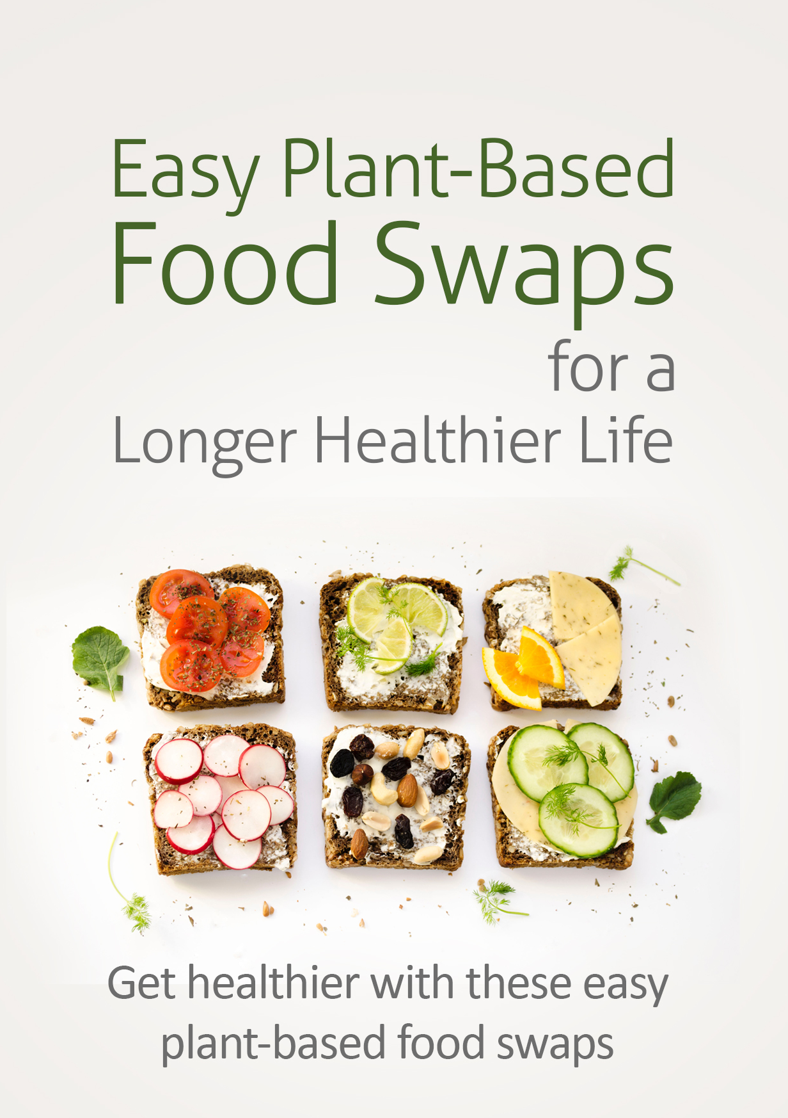
Try TheseEasyPlant-Based Food Swaps for a Longer, Healthier Life

Preservatives, trans fats and refined sugar, sodium, MSG and other potentially harmful ingredients are found in many processed foods. Highly processed “food-like” offerings deliver very few of the health-boosting nutrients, minerals and vitamins their natural alternatives provide.

This leads to a much higher rate of contracting diabetes, some cancers and heart conditions. You’re more likely to develop Alzheimer's, Parkinson's and other neurological disorders with these ingredients in your diet. A long list of other serious health problems is also linked to highly processed foods.

On the other hand, a plant-based diet has been directly linked to a
longer, healthier life.

Your internal processes work properly, meaning your external body looks and feels strong and healthy. Your brain is sharper than if you ate fast foods and processed foods. You drastically reduce the risk of developing all of the dangerous health conditions listed above.

Still, you have to wonder if you'll be trading flavorful, delicious foods for flavorless alternatives you feel like you're eating because you HAVE to, not because you WANT to.

The good news is this - eating a healthy, plant-based diet doesn't mean missing out on the foods, the flavors and textures that you love.

Just swap out the following healthy, plant-based ingredients and food products for their less healthier counterparts you're currently eating. Your health will get a boost without your taste buds becoming upset.(NOTE: Choose organic when possible. This ensures the safest, cleanest possible plant-based meals.)

Use Seitan or Tofu as a Meat Swap

Seitan makes a healthy replacement for beef. You can consider seitan the "vegetarian wheat meat" that closely resembles the texture of beef, steak and other red meats. Seitan was originally developed by 7th century Buddhist monks. They figured out how to separate gluten from wheat, and discovered that seitan made an excellent meat replacement.

Seitan took off as a meat substitute in the 1970s. That's when America's counterculture vegetarian movement recognized it as a high source of protein that was inexpensive and filling.

Tofu is a bean curd made from water, soybeans and a curdling or coagulating agent. It's often used in sweet or savory dishes as a meat substitute, and works great in stir fries in place of chicken. It is an excellent protein source and delivers high levels of calcium. Tofu's rather porous, and is therefore capable of absorbing flavors, spices and marinades effectively.

The word tofu is synonymous with vegetarianism, and this meat replacement is affordable, nutritious and versatile. It's even honored by an annual festival in Los Angeles, California.

Use These Syrups in Place of Honey

Honey is made by bees. Maple and agave syrups are plant-based sweeteners. Date syrup and pure vegetable purees can also effectively replace honey. As with all other plant-based swaps, make sure you’re choosing natural, organic, preservative-free products.

Swap Greens for Flour Wraps

Wraps usually begin with a large, flat, circular grain, corn or white flour-based outer shell. You place your meat, fish, vegetables, condiments and other toppings on this base, and then “wrap” the outer layer over the inner ingredients. Then tuck the ends over to make a spill-proof, tubular, handheld alternative to a sandwich.

The problem with many wrap exteriors is that they often contain animal and dairy by-products.

Greens with large leaves like cabbage, butter lettuce, kale and collard greens, make healthy plant-based alternatives to processed wraps. You wrap your ingredients in a large leaf of those vegetables. The wonderful anticancer compounds and antioxidants found in leafy greens are just extra benefits.

Ditch Dangerous Dairy for Healthy Nondairy Options

Swap out dairy milk for soy, coconut or almond milk. When you were growing up, your parents probably told you to drink a lot of whole milk. Don't blame them for giving you the wrong information.

They were simply passing on what they were told by their parents, and in many cases, the nutrition and food authorities in the country where they were raised. We now know that dairy can cause constipation and gas, bloating and diarrhea. It's been linked to higher rates of obesity and chronic conditions like diabetes and some cancers.

That is why it's a good idea to make a plant-based swap of soy, almond or coconut milk for dairy milk. Just make sure your nondairy food product is free from carrageenan. That substance has been linked to digestive problems, from mild to severe. Vegan cheeses and yogurts also effectively replace their traditional dairy-based counterparts.

In with the Cauliflower for Wraps, Pizza Crust, Rice, Couscous, Potatoes

You just discovered how large vegetable leaves make excellent wrapping material. Did you know you can use cauliflower the same way? Natural, organic cauliflower can be ground down into powdered form using a food processor or food chopper. It can then be used as a base for breads and wraps. It makes a great swap for dairy-based pizza crusts filled with white flour and preservatives.

Cauliflower can also be used as an alternative to rice (even couscous). Use a food chopper, and stop when the cauliflower has been ground down to the size of rice grains. Sauté in a little coconut oil for a tasty and super-healthy rice alternative.

The versatile cauliflower is not done yet. You can swap it into a multitude of dishes where potatoes are traditionally used. The first time you taste mashed cauliflower instead of mashed potatoes, you'll probably be shocked by the similarity in texture and taste.

One good book to help you realize the true versatility of cauliflower in a plant-based approach to nutrition is "Cauliflower Cookbook: Top 50 Most Delicious Cauliflower Recipes - Superfood Recipes Book 17". It's available on Amazon for immediate download, currently just $0.99. This swap is so popular (and healthy) that there are hundreds of retail cauliflower-flour products available so you don't have to make your own.

Coconut or Almond Flour instead of White Flour

White flour is not only devoid of almost all nutrition, it has also had its nutrients replaced by unhealthy chemicals, preservatives and by-products. Why do food manufacturers use it? White flour lasts longer on grocery store shelves when all its nutrients have been taken out.

Even when you see a sign that says “enriched” on a white flour product, that enrichment occurs only after all the natural goodness has been removed. Replacing white flour with coconut, almond or some other nut flour makes for a healthier, plant-based choice. You can additionally opt for a black bean purée instead of white flour.

Healthy Plant-Based Sugar Replacements

Sugar has been linked to diabetes, overweight, obesity, cancer and a long list of health problems. This can be avoided. There are wonderful natural sweeteners that can take the place of refined, processed sugar. Every cup of sugar you replace with a cup of unsweetened applesauce cuts more than 600 calories from your waistline! Just be sure you read your food labels, and avoid highly processed varieties.

Vanilla extract is an often overlooked sugar replacement. You can replace up to half the sugar in any recipe with vanilla extract without dramatically changing the flavor or taste. For every cup of sugar replaced you eliminate 400 calories. In baked goods and other recipes, swap 1 cup of sugar with 1 teaspoon of vanilla extract + 1/2 cup of sugar.

The Stevia plant is 300 times sweeter than sugar.

Another eyebrow-raising fact is that this natural plant, as sweet as it is, delivers 0 calories! For each cup of sugar in a recipe, replace with 1 teaspoon of liquid Stevia or 2 tablespoons of Stevia powder. (NOTE:Don’t be confused by the similarly marketed Truvia, which claims to have Stevia in it. There is very little Stevia contained in Truvia.)

Monk fruit sweetener and coconut sugar are another couple of healthy plant-based sugar swaps you may want to try.

Ban Butter and Use an Avocado or Banana Purée Instead

Though it may not seem possible, you can replace butter with plants. A purée made from bananas or avocados contains up to 5 times fewer fat grams (as well as 400% fewer calories!) than traditional butter.

This swap can be used in all types of recipes, from baked goods to casseroles and anywhere else your recipe requires butter. Make an even swap, 1 cup of butter for 1 cup of banana or avocado purée. Be aware that this usually reduces cooking time up to 25%.

Swap Beef Burgers for Veggie-Based Patties

The hamburger ... a bun, the condiments and toppings of your choice, and at least one patty of ground meat, usually beef. Yummy, versatile and full of protein, the hamburger can be pan-fried, flame-broiled or barbecued. Since immigrants from Hamburg, Germany introduced a broiled beef and onion beef burger patty to Ohio in the early 1800's, the hamburger has been a commonplace and inexpensive item at American dinner tables.

Worldwide the hamburger is a popular meat-based protein source. Unfortunately, studies in recent years have pointed to animal-based proteins as directly linked to higher than average cancer rates. The good news? That elevated cancer risk can be prevented (and cancer even reversed) with a plant-based diet.

Thanks to veggie-loving burger worshippers, you can still get that beefy burger taste ... with a plant-versus-beef patty. Make the following veggie-for-beef swaps for some surprisingly great tasting plant burgers.

• Black beans
• Kidney beans
• Mixed vegetables
• Tofu
• Portobello mushrooms
• Potatoes
• Eggplant

There are also some great-tasting, healthy pre-made veggie burgers. The Huffington Post conducted a taste test, and of the dozens of frozen veggie burgers tested, here are the top 5 for taste.

- Dr. Praeger's Kale Veggie Burger
- Gardein Ultimate Beefless Burger
- Hilary’s Eat Well World’s Best Veggie Burger
- Gardenburger Original Veggie Burger
- Morningstar Garden Veggie Patty

Skip the Fruit Juice and Choose the Whole Fruit Instead

Manufactured, processed fruit juices are always marketed as healthy. In most cases, however, you are just looking at tons of sugar in disguise. Fruit juices will many times claim that they have fiber and more Omega 3s or other healthy nutrients added. Unfortunately, often times that fiber is synthetic and extremely hard to digest.

This causes bloating and digestive problems. Eating sugar can lead to overweight, obesity, cancer and heart problems. Always choose to make your own juice at home, using natural, fresh, organic fruits. Eating real fruits can help you lose weight and manage a healthy body weight. This is because natural fruit is full of fiber, vitamins and minerals which make you feel full quickly, and limit your calorie intake.

Go Fresh over Frozen When You Can

Some frozen meals make boastful health claims. Even so, they are usually cram-packed full of extremely high levels of sodium, preservatives and man-made chemicals you don't need in your body.

Any time you eat fresh plants over frozen, canned, or processed alternatives, you're doing your body a favor. It takes longer to prepare a meal using natural, fresh vegetables than it does heating up their frozen counterparts. However, this is the right move every time as far as your health is concerned.

